Sunday | Monday | Tuesday | Wednesday |  | Thursday | Friday | Saturday
 |  |  |  |  | 1  May Day | 2 | 3
4 | 5  Cinco de Mayo | 6 |  | 7 | 8 | 9 | 10
11  Mother’s Day  National Skill Nursing Care Week | 12 | 13 |  | 14 | 15 | 16 | 17  Armed Forces Day
18 | 19  Victoria Day (Canada) | 20 |  | 21 | 22 | 23 | 24
25 | 26  Memorial Day | 27 |  | 28 | 29 | 30 | 31

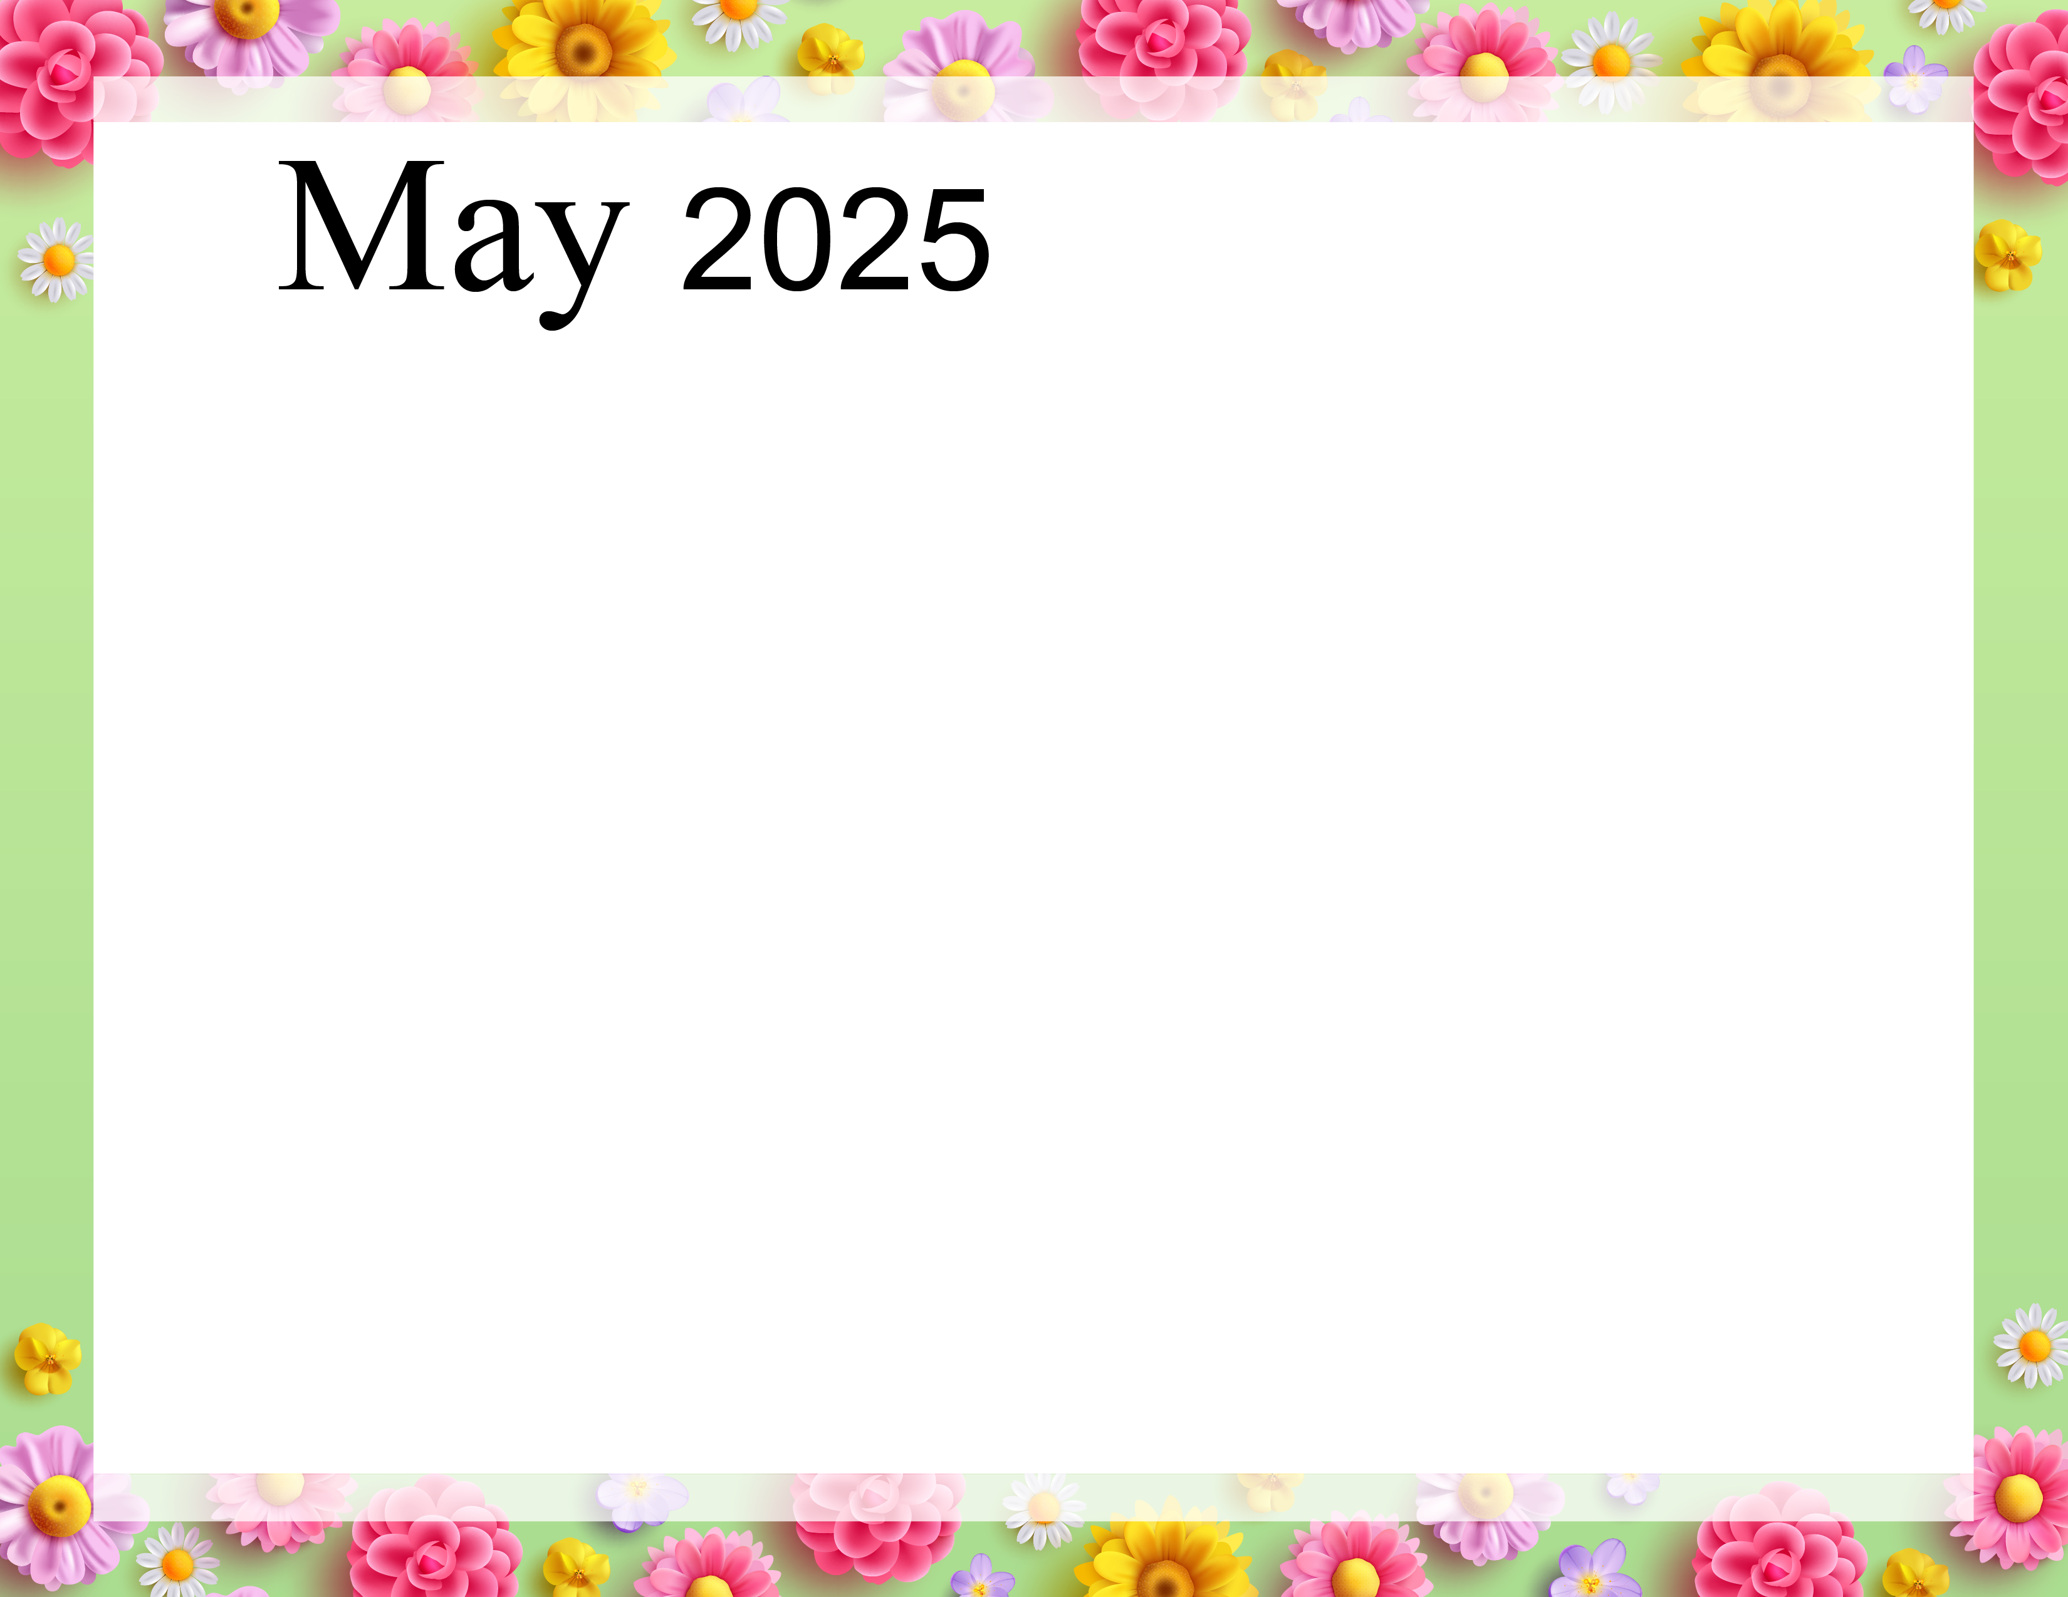 |  |  |  | 6:30-Coffee (FD)  8:00-Breakfast Out  10:00-Drinks (SDR)  11:15-Hair Appts  1:30-Rides w/Donna  2:30-Snack & Drinks (SDR)  7:00-Mennonite Youth Chorus | 6:30-Coffee (FD)  10:00-Drinks (SDR)  1:30-Bingo  2:30-Snack & Drinks  (SDR)  6:00pm-Races Outlaw Speedway  $13.00 Admission | 6:30-Coffee (FD)  10:00-Drinks (SDR)  2:30-Snack & Drinks (SDR)  Independent Activities
6:30-Coffee (FD)  8:00-Church & Lunch out  1:30-Trips out  2:30-Snack & Drink (SDR) | 6:30-Coffee (FD)  9:00-Walks  10:00-Drinks (SDR)  10:30-Bingo  1:30-Cinco De Mayo Snacks (AR)  2:30-Snack & Drinks (SDR) | 6:30-Coffee (FD)  9:00-Bible Study (FR)  10:00-Drinks (SDR)  11:00-Lunch Out  1:30-Walmart Trip  2:30-Snack & Drinks (SDR) | 6:30-Coffee (FD)  9:00-Walks  10:00-Drinks (SDR)  10:30-Bingo  1:30-Craft (Bonnets)  2:30-Snack & Drinks (SDR) | 6:30-Coffee (FD)  9:00-Walk to the Falls  10:00-Drinks (SDR)  Woman’s Day Out  2:30-Snack & Drinks (SDR) | 6:30-Coffee (FD)  9:00-Exercise  10:00-Drinks (SDR)  10:30-Bingo  1:30-Movie & Snacks  2:30-Snack & Drinks (SDR) | 6:30-Coffee (FD)  10:00-Drinks (SDR)  2:30-Snack & Drinks (SDR)
6:30-Coffee (FD)  10:00-Drinks (SDR)  2:30-Snack & Drinks (SDR)  Independent Activities | 6:30-Coffee (FD)  9:00-Walks  10:00-Drinks (SDR)  10:30-Bingo  1:30-Trip to Ice Cream Store  2:30-Snack & Drinks (SDR) | 6:30-Coffee (FD)  9:00-Bible Study (FR)  10:00-Drinks (SDR)  10:30-Walmart Trip  1:30-Resident Council & Food Committee  2:30-Snack & Drinks  (SDR)  3:00-Pastor Carl | 6:30-Coffee (FD)  9:00-Exercise  10:00-Drinks (SDR)  10:30-Bingo  1:30-Cornhole  2:30-Snack & Drinks (SDR)  7:00-Mennonite Chorus | 6:30-Coffee (FD)  9:00-Walks  10:00-Drinks (SDR)  10:30-Music w/ George Mann  11:15-Hair Appts  1:30-Ladies Tea  2:30-Snack & Drinks (SDR) | 6:30-Coffee (FD)  10:00-Drinks (SDR)  10:30-Music w/ Michael Burrell  1:30-Bingo  2:30-Snack & Drinks (SDR)  6:00pm-Races Outlaw Speedway  $15.00 Admission | 6:30-Coffee (FD)  10:00-Drinks (SDR)  2:30-Snack & Drinks (SDR)  Thunder in the Glen  (Clute Park)  Independent Activities
6:30-Coffee (FD)  8:00-Church & Lunch out  1:30-Trips out  2:30-Snack & Drink (SDR) | 6:30-Coffee (FD)  9:00-Walks  10:00-Drinks (SDR)  10:30-Bingo  1:30-Baking Club  2:30-Snack & Drinks (SDR) | 6:30-Coffee (FD)  9:00-Bible Study (FR)  10:00-Drinks (SDR)  10:30-Walmart Trip  1:30-Cards  2:30-Snack & Drinks (SDR) | 6:30-Coffee (FD)  9:00-Walks  10:00-Drinks (SDR)  10:00-Visits with Father Jeff  10:30-Bingo  1:30-Donuts & Dialogue  2:30-Snack & Drinks (SDR) | 6:30-Coffee (FD)  7:30-Breakfast in AR  10:00-Drinks (SDR)  11:15-Hair Appts  1:30-Movie & Snack  2:30-Snack & Drinks (SDR) | 6:30-Coffee (FD)  10:00-Drinks (SDR)  2:30-Snack & Drinks (SDR)  Independent Activities | 6:30-Coffee (FD)  10:00-Drinks (SDR)  2:30-Snack & Drinks (SDR)  Independent Activities
6:30-Coffee (FD)  10:00-Drinks (SDR)  2:30-Snack & Drinks (SDR)  Independent Activities | 6:30-Coffee (FD)  10:00-Drinks (SDR)  2:30-Snack & Drinks (SDR)  Independent Activities | 6:30-Coffee (FD)  8:30-Walmart Trip  10:00-Drinks (SDR)  10:30-Bingo  1:30-Ice Cream Sundaes (AR)  2:30-Snack & Drinks (SDR) | 6:30-Coffee (FD)  9:00-Walk to the Falls  10:00-Drinks (SDR)  10:30-Bingo  11:30-Lunch in AR  2:30-Snack & Drinks (SDR) | 6:30-Coffee (FD)  9:00-Exercise  10:00-Drinks (SDR)  10:30-Cards  11:15-Hair Appts  1:30-Birthday Party  2:30-Snack & Drinks (SDR) | 6:30-Coffee (FD)  10:00-Drinks (SDR)  1:30-Bingo  2:30-Snack & Drinks (SDR)  6:00pm-Races Outlaw Speedway  $13.00 Admission | 6:30-Coffee (FD)  10:00-Drinks (SDR)  1:30-Music with Mario  2:30-Snack & Drinks (SDR)
All activities are in the Sunroom unless noted otherwise.

