Sunday | Monday | Tuesday | Wednesday |  | Thursday | Friday | Saturday
 | 1  Labor Day | 2 |  | 3 | 4 | 5 | 6
7  Grandparents Day | 8 | 9 |  | 10 | 11 | 12 | 13
14 | 15 | 16 |  | 17 | 18 | 19 | 20  Oktoberfest Begins
21 | 22  Rosh Hashanah  Autumn Begins | 23 |  | 24 | 25 | 26 | 27
28 | 29 | 30

 | 6:30-Coffee Cart  10:00-Drink Time  2:30-Drink & Snack  Independent Activities | 6:30-Coffee Cart  9:00-Exercise  10:00-Drinks  10:30-Bible Study (FR)  1:30Yatzee (SR)  2:30-Snack & Drinks (SDR) | 6:30-Coffee Cart  9:00-Walk to Falls  10:00-Drinks  10:30-Crafts (AR)  1:30- Bingo  2:30-Snack & Drinks (SDR) | 6:30-Coffee Cart  9:00-Exercise  10:00-Drinks  10:30-Music with Michael Burrell  11:15-Haircuts  1:30-Uno (AR)  2:30-Snack & Drinks (SDR) | 6:30-Coffee Cart  9:00-The Chosen (AR)  10:00-Drinks  10:30-Grand Prix Festival  1:30- Bingo  2:30-Snack & Drinks (SDR) | 6:30-Coffee Cart  10:00-Drink Time  2:30-Drink & Snack  Independent Activities
6:30-Coffee Cart  10:00-Drink Time  2:30-Drink & Snack  Independent Activities | 6:30-Coffee Cart  9:00-Exercise  10:00-Drinks  10:00-Apple Picking  1:30- Bingo  2:30-Snack & Drinks (SDR) | 6:30-Coffee Cart  9:00-Exercise  10:00-Drinks  11:15-Hair Appts  1:30-Resident Council & Food Committee  2:30-Snack & Drinks (SDR)  3:00 Pastor Carl | 6:30-Coffee Cart  9:00-Exercise  10:00-Drinks  10:30-Bake Sale  1:30- Bingo  2:30-Snack & Drinks (SDR)  7:00 Mennonite Chorus | 6:30-Coffee Cart  9:00-Walk to Falls  10:00-Drinks  10:30-  1:30-Baking Club (AR)  2:30-Snack & Drinks (SDR) | 6:30-Coffee Cart  9:00-The Chosen (AR)  10:00-Drinks  10:30 -Bingo  1:30- Movie & Snack  2:30-Snack & Drinks (SDR)  6:30-Outlaw Speedway | 6:30-Coffee Cart  10:00-Drink Time  2:30-Drink & Snack  Independent Activities
6:30-Coffee Cart  10:00-Drink Time  2:30-Drink & Snack  Independent Activities  National Cream filled  donut day! | 6:30-Coffee Cart  9:00-Uno  10:00-Drinks  10:30-Oakhill trip  1:30- Bingo  2:30-Snack & Drinks (SDR) | 6:30-Coffee Cart  9:00-Memory care  Play-Doh  10:00-Drinks  10:30-Bible Study  1:30-Baking Club (Apple Butter)  2:30-Snack & Drinks (SDR) | 6:30-Coffee Cart  9:00-Exercise  10:00-Drinks  11:00-Pizza at the Pier  1:30- Bingo  2:30-Snack & Drinks (SDR) | 6:30-Coffee Cart  9:00-Ball Toss  10:00-Drinks  11:15-Haircuts  1:30-Dunkin Donuts Club (coffee/donuts) AR  2:30-Snack & Drinks (SDR) | 6:30-Coffee Cart  9:00-The Chosen (AR)  10:00-Drinks  10:30- Bingo  1:30- Trip to Ice Cream Store  2:30-Snack & Drinks (SDR)  6:30-Outlaw Speedway | 6:30-Coffee Cart  10:00-Drink Time  2:30-Drink & Snack  Independent Activities
6:30-Coffee Cart  10:00-Drink Time  2:30-Drink & Snack  Independent Activities | 6:30-Coffee Cart  9:00-Exercise  10:00-Drinks  10:00-Apple Picking  1:30- Bingo  2:30-Snack & Drinks (SDR) | 6:30-Coffee Cart  9:00-Memory Care Game  10:00-Drinks  10:30-Bible Study  1:30-Donuts & Dialogue  2:30-Snack & Drinks (SDR) | 6:30-Coffee Cart  9:00-Exercise  10:00-Drinks  10:00-Catholic Mass  1:30- Bingo  2:30-Snack & Drinks (SDR) | 6:30-Coffee Cart  9:00-Ball Toss  10:00-Drinks  10:30-Music w/George  11:15-Haircuts  1:30-Movie & Snacks  2:30-Snack & Drinks (SDR) | 6:30-Coffee Cart  9:00-The Chosen (AR)  10:00-Drinks  10:30-Make your own key lime pie!  1:30- Bingo  2:30-Snack & Drinks (SDR)  Key Lime Pie Day! | 6:30-Coffee Cart  10:00-Drink Time  2:30-Drink & Snack  Independent Activities
6:30-Coffee Cart  10:00-Drink Time  2:30-Drink & Snack  Independent Activities | 6:30-Coffee Cart  9:00-Exercise  10:00-Drinks  10:30-Walmart trip  1:30- Bingo  2:30-Snack & Drinks (SDR) | 6:30-Coffee Cart  7:30-Breakfast in AR  10:00-Drinks  1:30-Yatzee  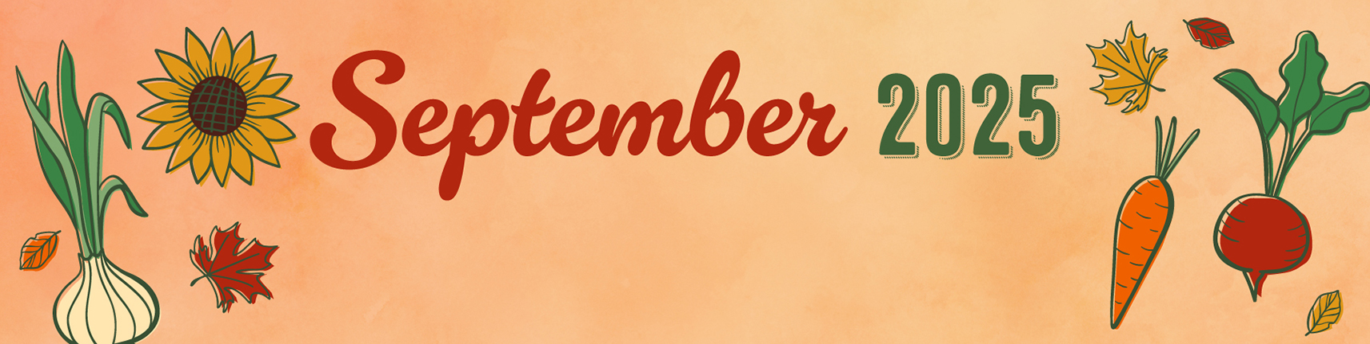  2:30-Snack & Drinks (SDR) | Please see Donna or Robin with any questions  Or call 607-535-7165
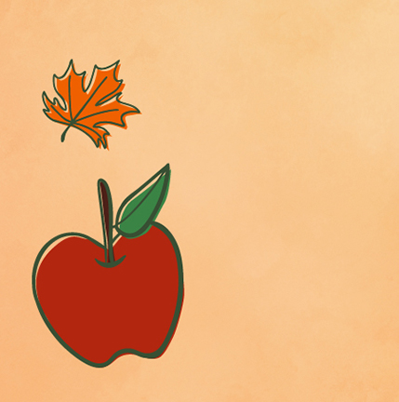
All activities are in the sunroom unless otherwise noted.

